
Read 180: Volume Control Trouble-Shooting

Headphones / Microphones and Volume Control Settings (Students can be instructed on trouble-shooting volume issues.)

- Make sure all connections are secure
- Restart the computer
If restarting the computer does not result in resolve the problem with sound and recording, follow the trouble-shooting directions below:

- Make sure Mute is off
  - Left click once on lower right Volume Control (the speaker icon). Uncheck Mute
  - Confirm that Volume is set at an appropriate level
- Confirm that Microphone Properties are set correctly
  - Double-click on the Volume Control

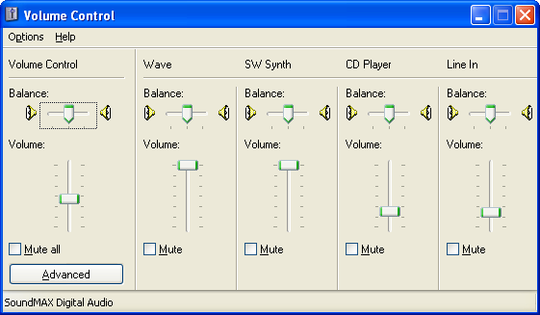

(Directions continue on next page.)


  - Go to Options and select Properties. Make sure that Microphone is selected and click OK.

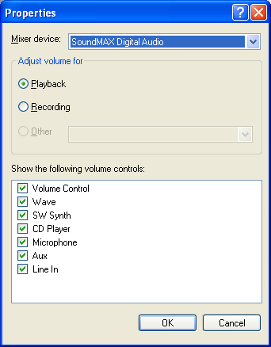
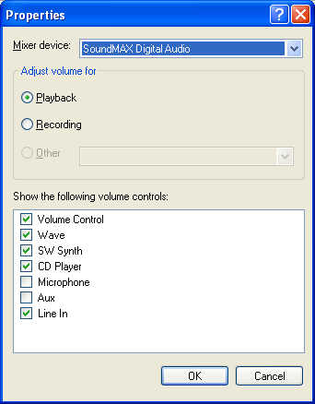

  - Deselect Mute. Close the Volume Control window.

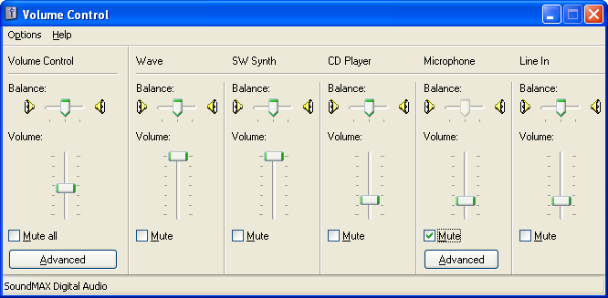

  - Click on the Advance button to make sure that the Mic Boost is selected.
  - Email HelpDesk if the student is still unable to record.

Trouble-Shooting for the USB Headphones

- If you are using a USB headphone and sound is coming from the computer and not the headphone (or sound is on both), double-click on the Volume Control icon and then the Advanced button in the lower left of the dialog box.
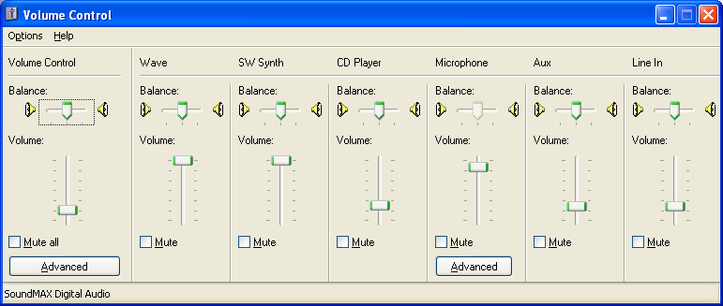

- Select 1 Digital Output. Then click on the Close button.
